**Soldering station**

|  |  |
| --- | --- |
| Author | Asadullah Chaudhry |

Content

1. Introduction 1

2. Material and methods 2

2.1 Bill of Materials: 3

2.2 Method: 4

3. Results 4

3.1 Device description 5

3.1.1 Altium schematic 5

3.1.2 Software 6

3.1.3 Circuit 6

3.1.4 Power supply 6

3.2 Pcb Design 7

3.3 Fusion 360 8

4. Discussion 9

Reference list 9

# Introduction

The project is a soldering station with temperature regulation. This project allows progression in electronics. The soldering station has a few characteristics. It is temperature regulation ranges from 50°C to 450°C and it is also accurate. It uses a soldering tip which can be exchanged. The processor also continuously logs its data. The project idea and sources come from the magazine Elektor.

The schematic of the project’s PCB is also found in this magazine. This application note states the materials and methods used to build the station, a description of the end results and a discussion.

The application note is structured as follows: all the materials and methods that are used can be found/. This chapter also explains the purpose of each component.

# Material and methods

The project starts on the computer. The PCB need to be drawn and sent to a company, so they are going to create. Altium Designer 21.1.1 is commonly used to draw the schematic and create the PCB. That is why this software has to be used to draw the PCB.

The casing of the PCB is drawn in FUSION 360. This software is recommended for people who had close to no experience in 3D drawing. The case will partially print on a 3D-printer and partially assemble form wood from using a laser cutter. The 3D printer and the laser cutter were both located at the PXL makerspace in Diepenbeek. Most of the components are supplied by Mouser. This is a supplier that was recommended and used by many students from past years. One of the components that comes from there was the RT soldering iron. There are a few input and output ports on the PCB. Two of them are connected with a terminal block. The other one has a micro-USB connection. The name of the manufacturer that the PCB was sent to is JLCPCB. This was recommended by the teacher. An aluminium shield was also ordered since the PCB had a lot of service mounted devices, like SMD. This was used to apply soldering paste to the SMD pads. The components were never compared to any others because they came straight from the magazine. The transistors were used as switches because the processor could not handle high voltages. The used software and PCB manufacturer were recommended by the teachers. The suppliers were not easy to choose. Some could only be shipped in high quantities, while only one component is needed. Other suppliers have high shipping costs for a component that is less than 4 euros.

## 2.1 Bill of Materials:

The total billing is around 75 euros. The resistors are available at school, so they are not ordered online.

## 2.2 Method:

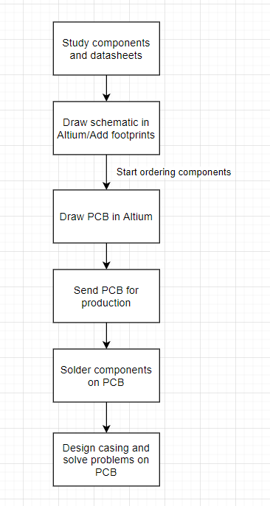

The first step in the building process is to study the components. Some specifications need to be learned before starting the project. Like if they are SMD. This means that they need to be solder on the board. Or they can be through hole components. This means they have pins that go through the board and are soldered on the other side. Anything that might be useful to remember when drawing the schematic should be noted. The datasheets provide information about their components. Next is to draw the schematic in Elektor on Altium. Some components will not have a footprint. This need to be downloaded from the internet. At this point, the components must look to be ordered because the delivery can take long depending on the supplier. When the schematic is finished, the PCB needs to be made. While drawing the PCB, the distance between pads and tracks must be considered. Information on the minimum and maximum distance is found on the website of the manufacturer. After that, the PCB needs to be produced by the manufacturer. It is best that the components arrive around this time. Because once the PCB arrives, the components need to be soldered on it. If there are any problems regarding the PCB or components they need to be solved now. Lastly, a casing needs to be drawn for the PCB to sit in. This is done in AutoCAD. It needs a unique logo that makes it stand out.

Figure 1: flowchart

# Results

## 3.1 Device description

### 3.1.1 Altium schematic

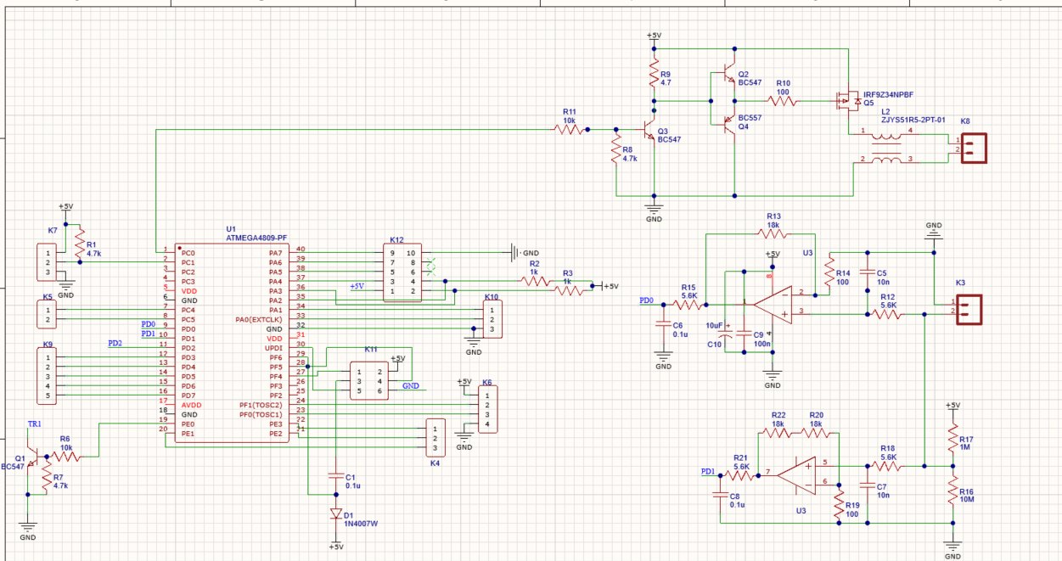

Figure 2: Scheme of pcb ATMEGA4809-PF

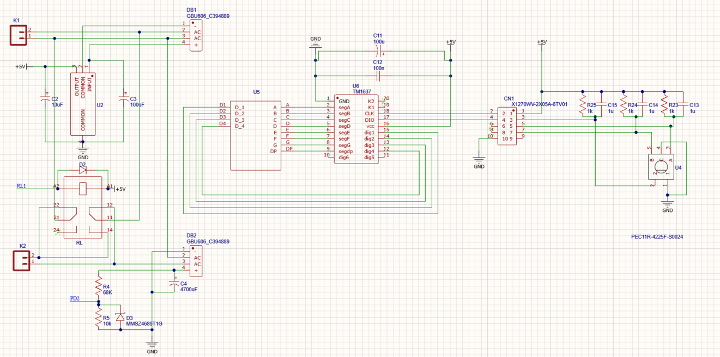

Figure 3: Scheme of pcb (4 digit)

The schemes shown above is based on figure 2 and 3. In this scheme all components are placed in several blocks. These components are also used in this project. This scheme is made in software Altium.

### 3.1.2 Software

The PCB is controlled by the ATMEGA4809-PF microprocessor on the board. This is programmed using the Arduino IDE on the PC. The PC will be connected to the micro-USB input on the board to send the program to the processor. The program is given by Elektor and is big. But it comes down to using Pulse Width Modulation (PWM) to regulate the temperature on the soldering iron. By turning the rotary encoder, the processor will read that input and change the pulse width of the output pin. This will result in a higher or lower average value at the output. Which will control the amount of voltage on the soldering iron. And that determines the heat. [2]

### 3.1.3 Circuit

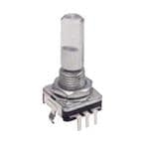It is necessary to install the ATmega4809. Timer A is a 16-bit timer with three PWM outputs that is set to an 8-bit timer with six outputs by default. This is fine for servos, however at 10 kHz, the power management of the soldering station isn't precise enough. As a result, in order to generate PWM signals in our soldering station, the timer A must be reset to 16bit mode.

Figure 4 : encoder

A timer interrupt routine is used to process the rotary encoder. The rotary encoder pins are read every 250 seconds, and the direction of rotation is determined by the last four pin states. Because the rotary encoder includes mechanical connections, it can twist impure sides at the ATmega's entrances, and if no filtering is used, there will always be some noise.

### 3.1.4 Power supply

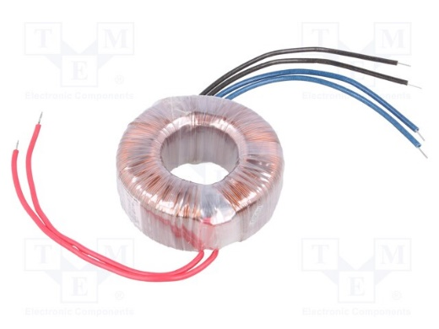

Figure 5: Transformer TST 60/002 INDEL

A 2 x 12 V, 60VA power supply is necessary to power the soldering station. A 12V wall adapter can be used when the cord is cut, and the wires are connected to K1. K1 is a 2-pole terminal block that is used to power the board. One big toroidal transformer (2 x 12 V, 60VA) powers the new soldering station, with the two secondary windings going to K1 and K2. The required type in the parts list also features two primary windings, allowing power to be supplied for both 115 VAC (primary windings in parallel) and 230 VAC (windings in series).

## 3.2 Pcb Design

Figure 6: Pcb design

In figure 6 the components are placed on the Pcb. They are organized how the Pcb will look like in reality, but in different colours. Everything is measured in software Altium. The purpose of these measurements are to work in another software to make a case for the result of the Pcb. In comparison with figure 2 and 3 the red and blue lines are visible on the Pcb to not make any mistakes by placing the components.

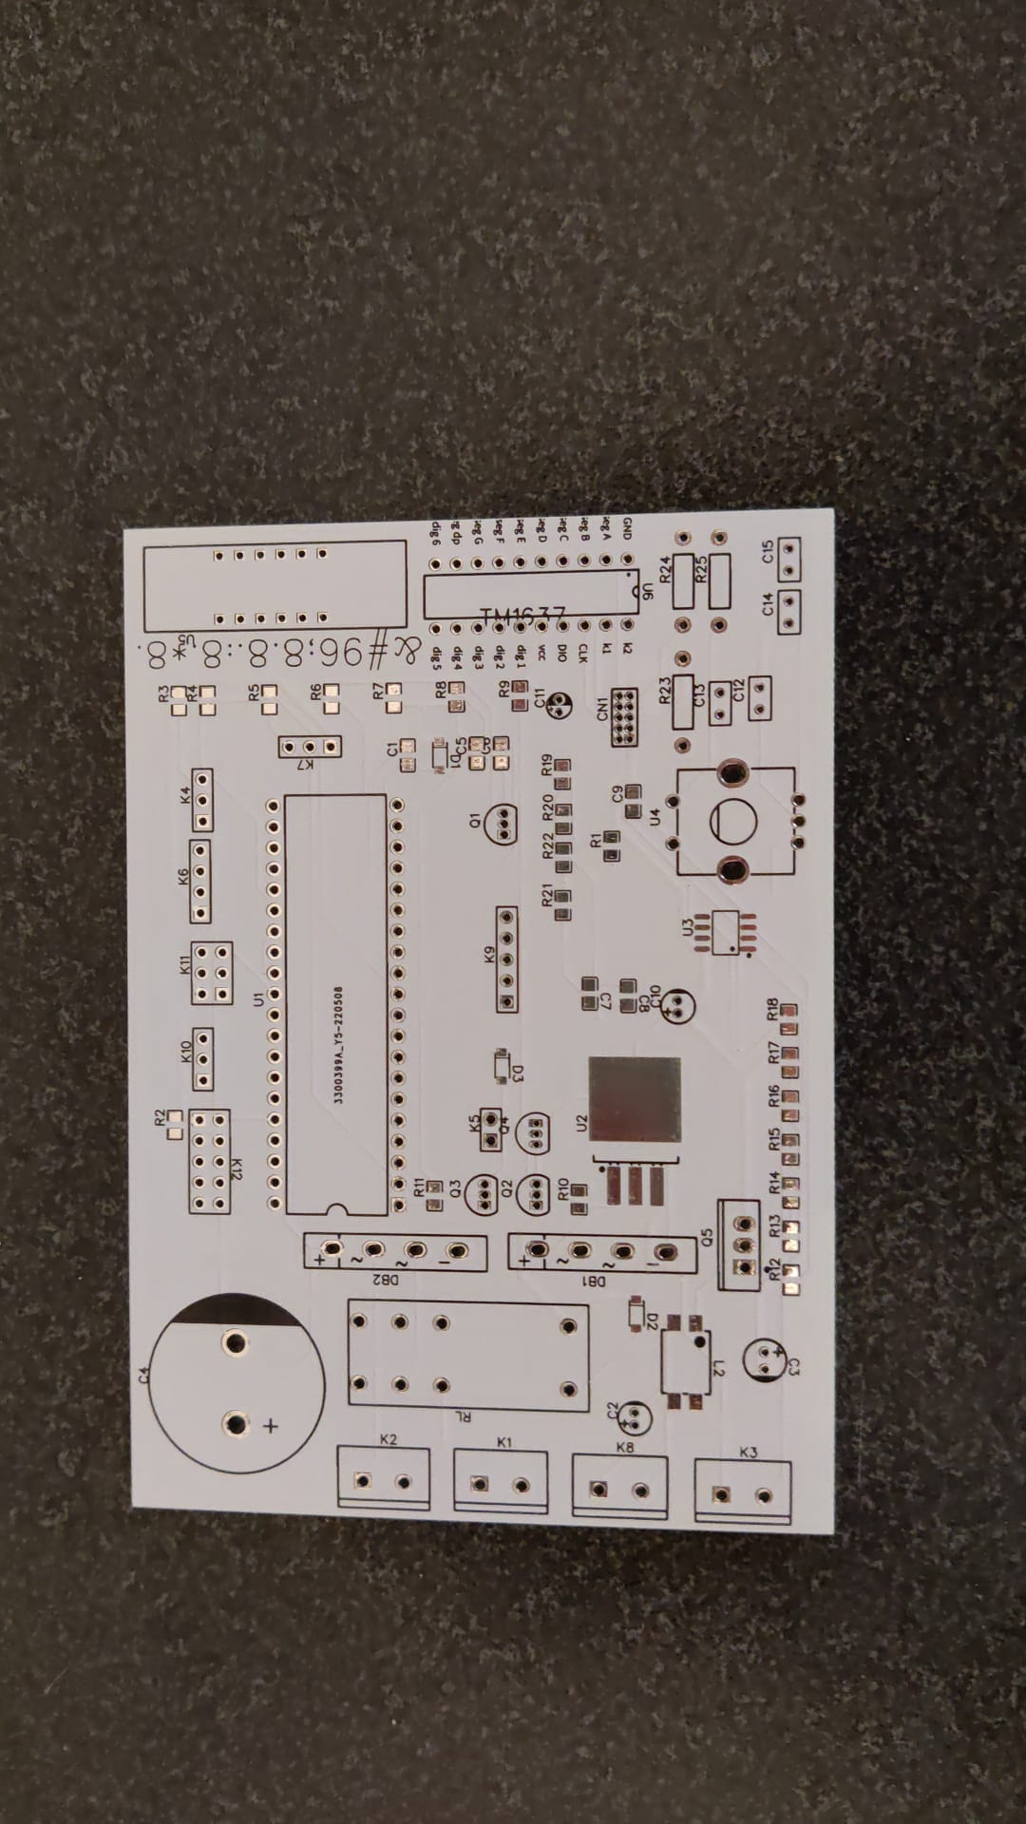

Figure 7: Pcb

## 3.3 Fusion 360

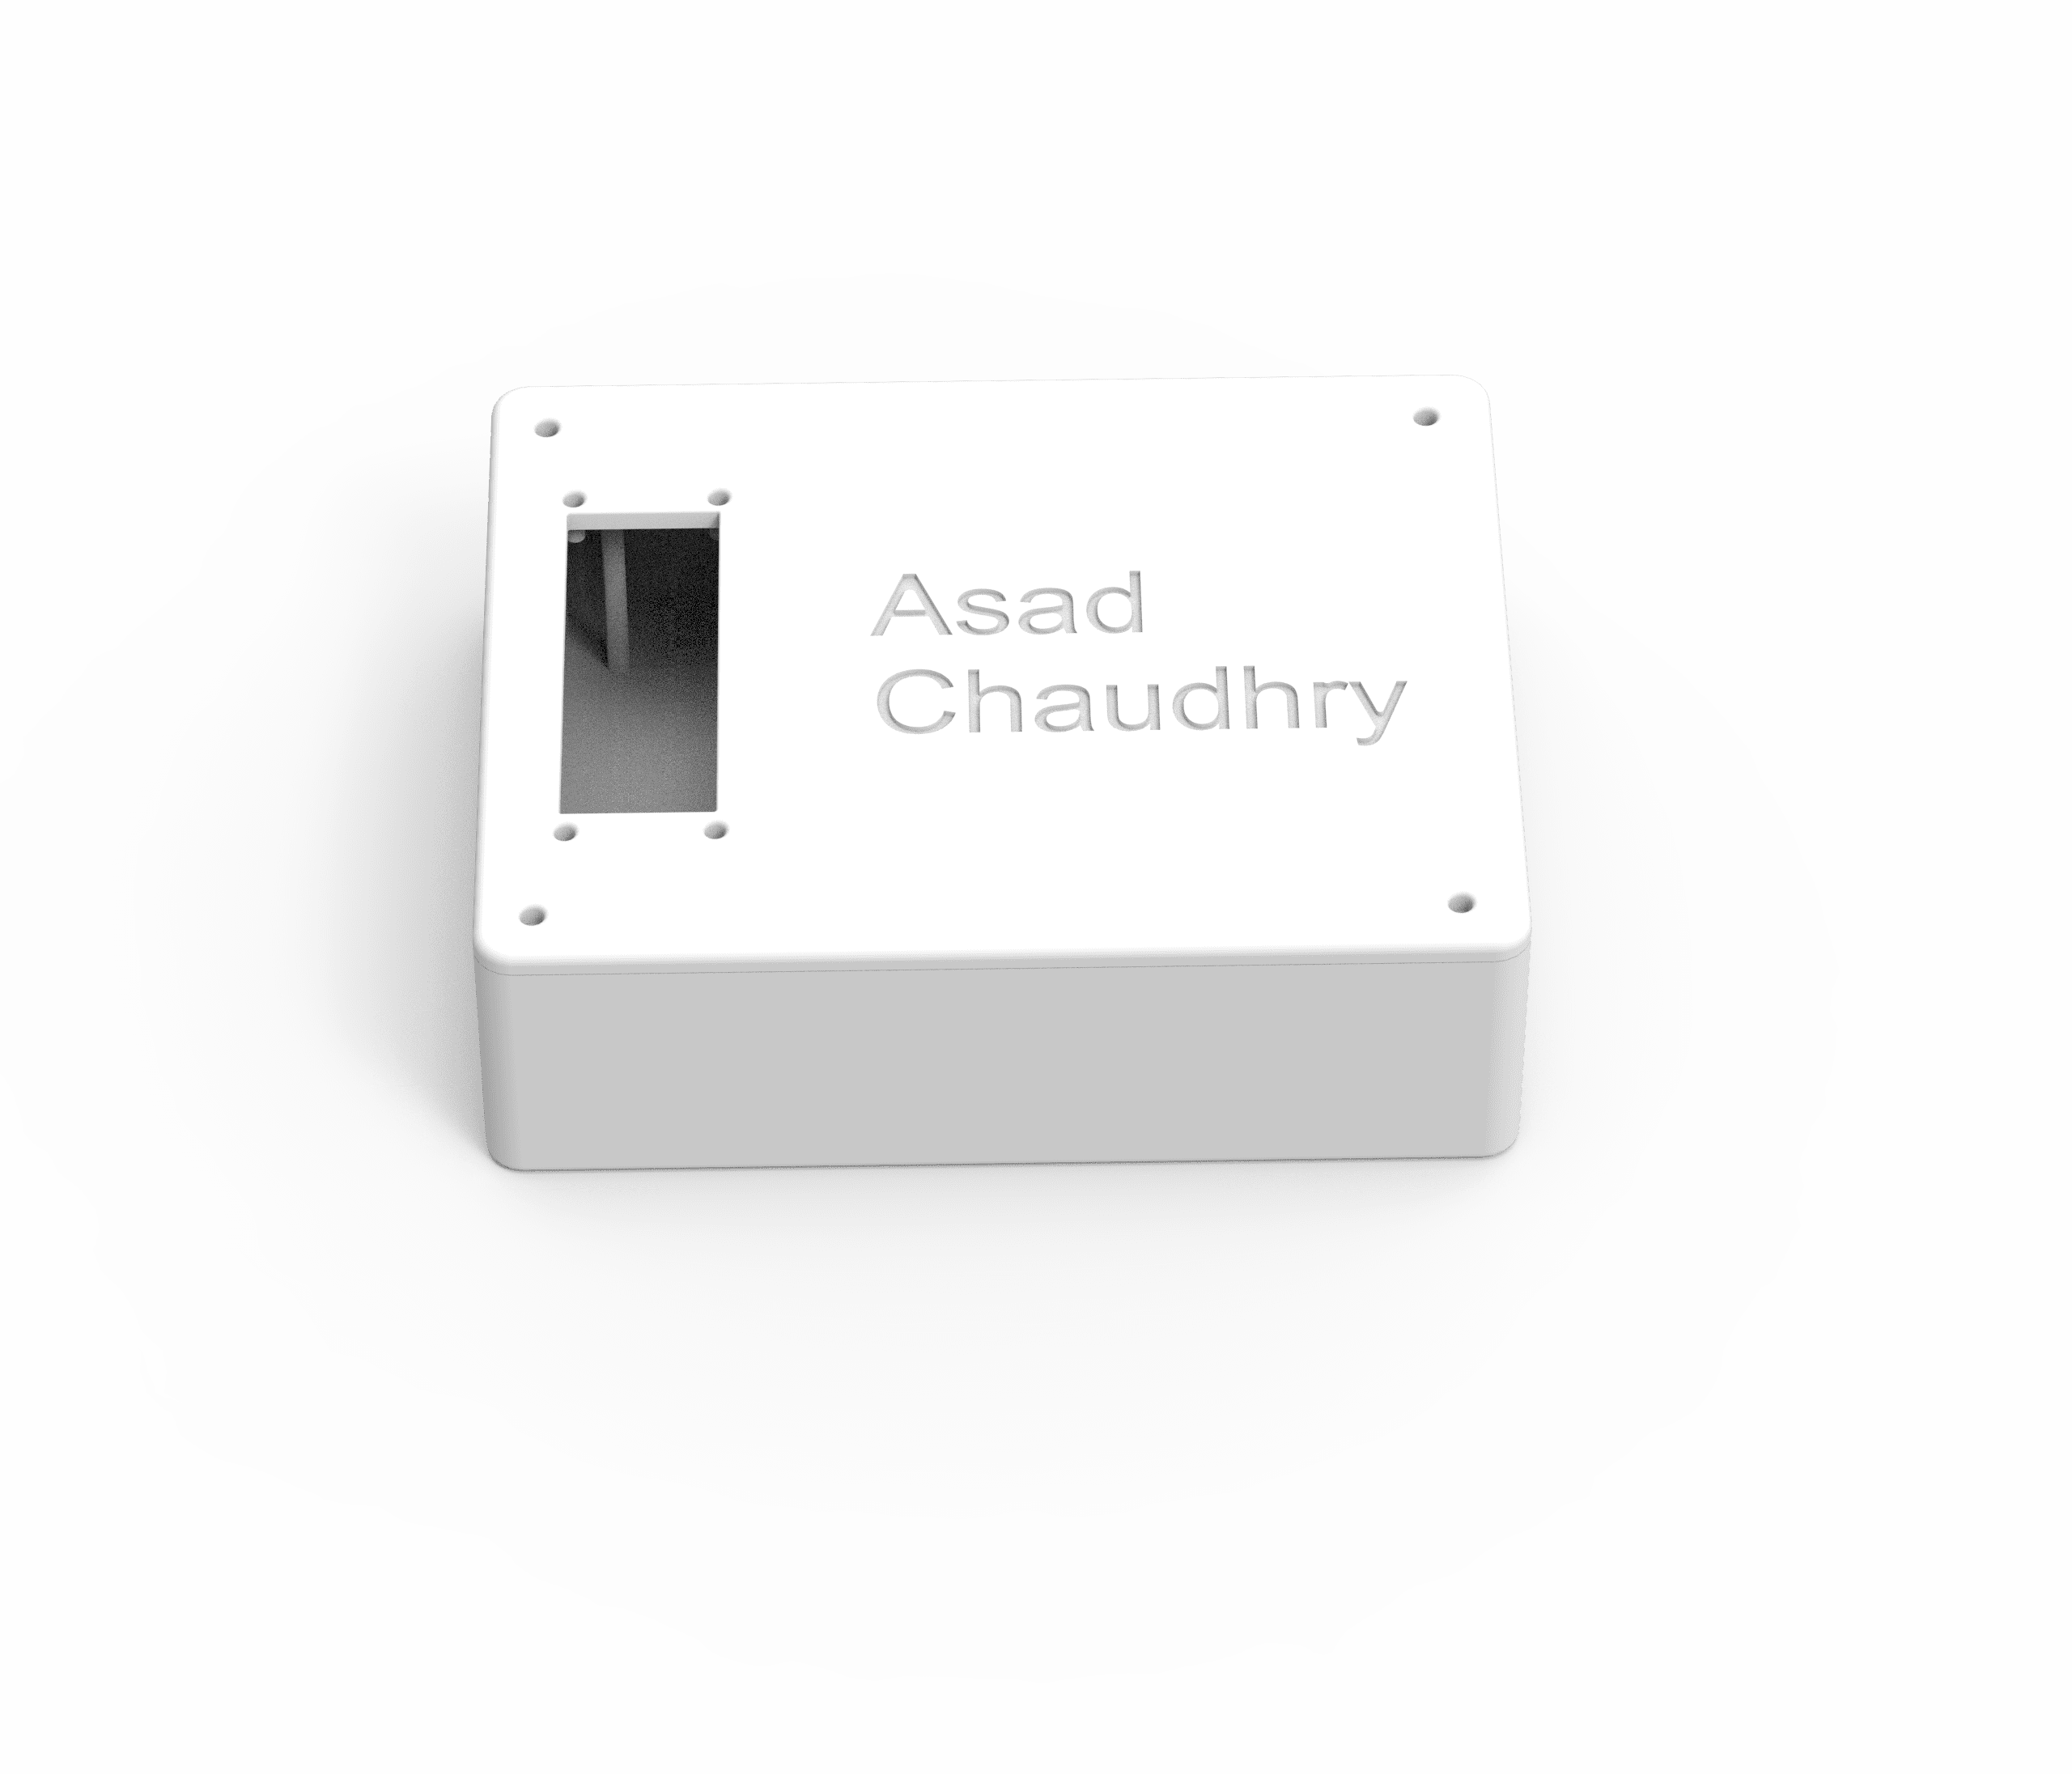

Figure 8: 3d case

The soldier station case consist of two parts; the base and the hardshell cover.

An innovative and safe way to store a pcb is by designing a case for it. The project that is showcased is the solder station case which is a handy way to safely store a pcb. This cover is specially designed for a specific type of pcb, which in this case has a rectangular form. The cover is securely held together on to the box with screws. This was also custom made so that the pcb can effortlessly fit in the case.

Additionally, the design of case includes opening on each side therefore allowing cables to easily attach on to it.

As a finishing touch, the program used enables the cover to personalise the cover. In this instance, the cover has been personalise with the name of the designer, Asad Chaudry.

This project was completed with the help of the program ‘Fusion’. This program was chosen due to the level of efficiency it provided. The program is widely utilised by many experts globally.

# 4. Discussion

The ordering of the components was the most difficult procedure due to the fact that the components used had to be precise. At first, the incorrect materials were ordered as well as experiencing difficulties acquiring components online. These were some of the challenges involved: some components had taken several months to arrive as the majority were only available to order in large quantities. Additionally, the delivery charges that were being asked for were not feasible. Another issue regarding an item that was out of stock occurred which caused a delay in the process that held up the entire order. This had been discovered a week after the order was placed. The supplier had to be contacted in order to arrange a substitute for the component. As a result of this, the exact component that was needed could not be obtained however, a similar mechanism was utilised.

It was necessary to use a 12V power supply however, only a circular connection plug was available with these. To expose the wires, the chord had to be amended which meant the power adapter could no longer be used for any other purpose.

Towards the end of the project, another issue was discovered. It was found that there was missing material which wasn’t available to order in such a short period of time. The RT soldering iron was an important tool to the project, which was requested and ordered however, did not get delivered.

Overall, the project did not run as efficiently as planned because of these limitations. Due to the nature of project, there was always a sense of unpredictability and instability. In order to complete the project successfully in future, it is imperative that the correct and accurate equipment is acquired in an appropriate amount of time which would eliminate these limitations.

# Reference list

|  |  |
| --- | --- |
| [2] | Elektor, „Zelfbouw-soldeertation met temperatuurregeling,” *Elektor,* vol. 1, nr. 0, p. 6, 2019. |